Name : Lingamarla Sathwika
Roll No : 26000095
Branch : CSE
Section : 2

Topic : Personal Portfolio Website
1. Aim:
To design a personal portfolio website using HTML and CSS to display personal information, educational qualifications, technical skills, hobbies, projects, achievements, resume, and contact details.
2. Description:
This project is a personal portfolio website created to introduce a student and showcase their skills and achievements. HTML is used to create the structure and content of the webpage, while an external CSS file is used to style the website. The website contains different sections that help visitors learn about the student's education, interests, technical knowledge, and projects.
3. Main Features:
- Navigation Bar: Provides links to Home, About, Education, Skills, Hobbies, Projects, and Contact.
- Profile Section: Displays the student's name, branch, and welcome message.
- About Me: Gives a brief introduction about the student.
- Educational Qualifications: Displays B.Tech, Intermediate, and SSC details.
- Technical Skills: Shows skills such as HTML, CSS, and Python.
- Hobbies: Displays personal interests and activities.
- Projects: Describes the projects created by the student.
- Achievements: Lists participation and web development practice.
- Resume: Provides a link to view the resume PDF.
- Contact Information: Displays email and branch details.
- Footer: Displays the portfolio title and technologies used.
4. HTML and CSS Used:
Tag / Property Purpose
<html> Defines the HTML document.
<head> Contains the title and stylesheet link.
<title> Sets the webpage title.
<link> Connects the external CSS file.
<body> Contains the webpage content.
<nav> Creates the navigation section.
<a> Creates links between sections.
<div> Groups related content.
<h1>, <h2>, <h3> Display headings.
<p> Displays paragraphs.
<ul> and <li> Display unordered lists.
<ol> Displays a numbered list.
<span> Groups inline content, such as skill labels.
<footer> Defines the bottom section of the webpage.
<Class> Groups elements for CSS styling.
id Identifies a specific section for navigation.
target="_blank" Opens the resume link in a new tab.

5. Conclusion:
This project demonstrates how HTML and CSS can be used to create a personal portfolio website. It helps students understand webpage structure, navigation, lists, external stylesheets, and hyperlinks while presenting their educational background, skills, and achievements professionally.
Output :
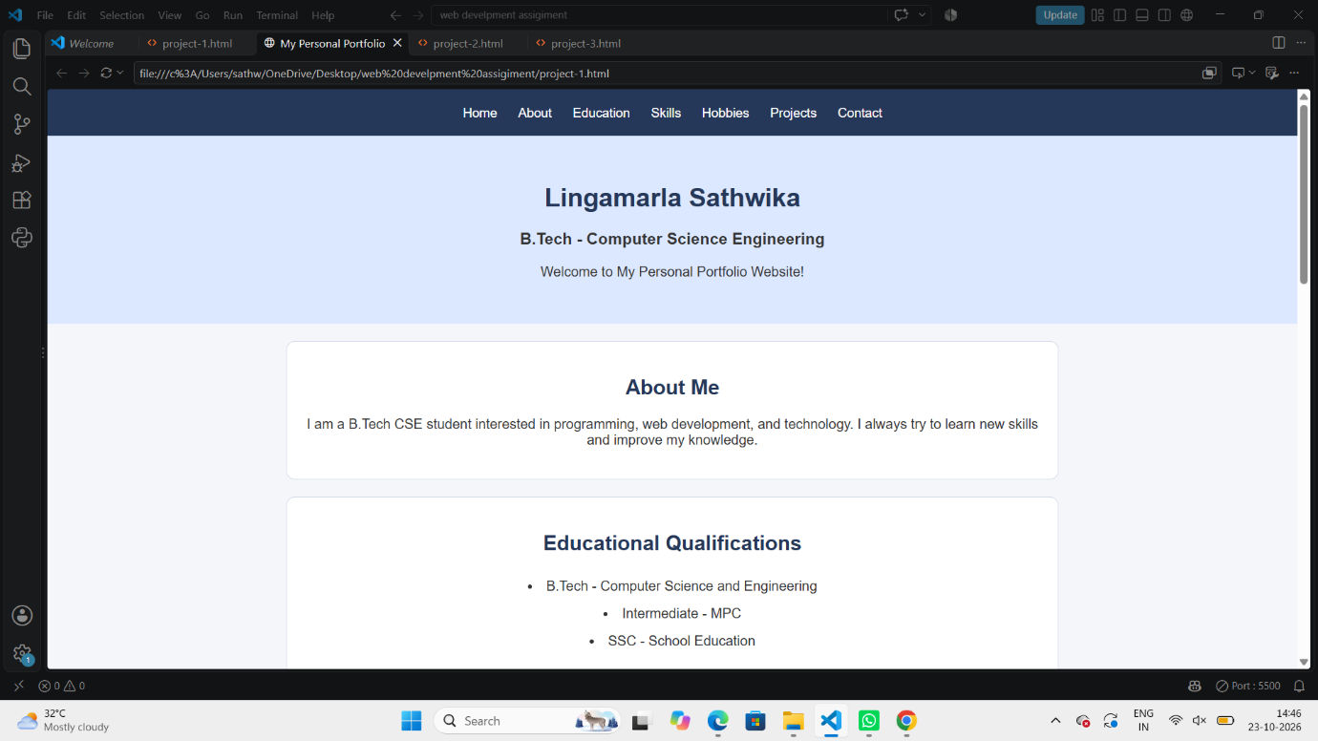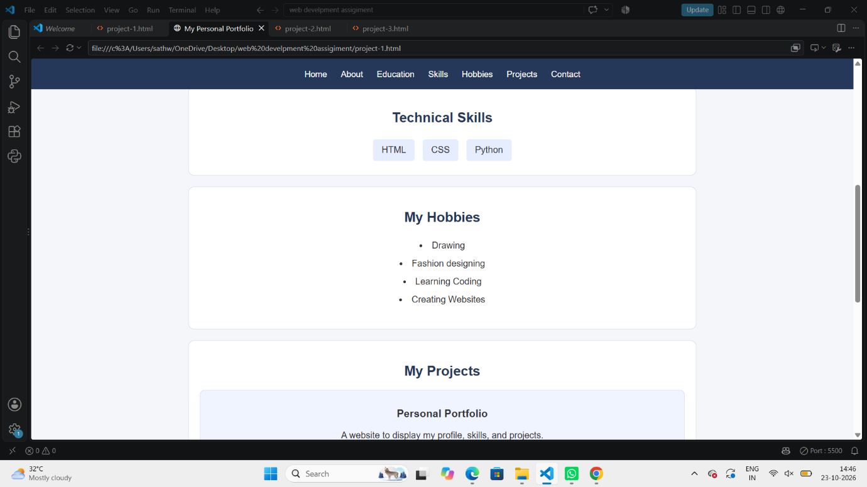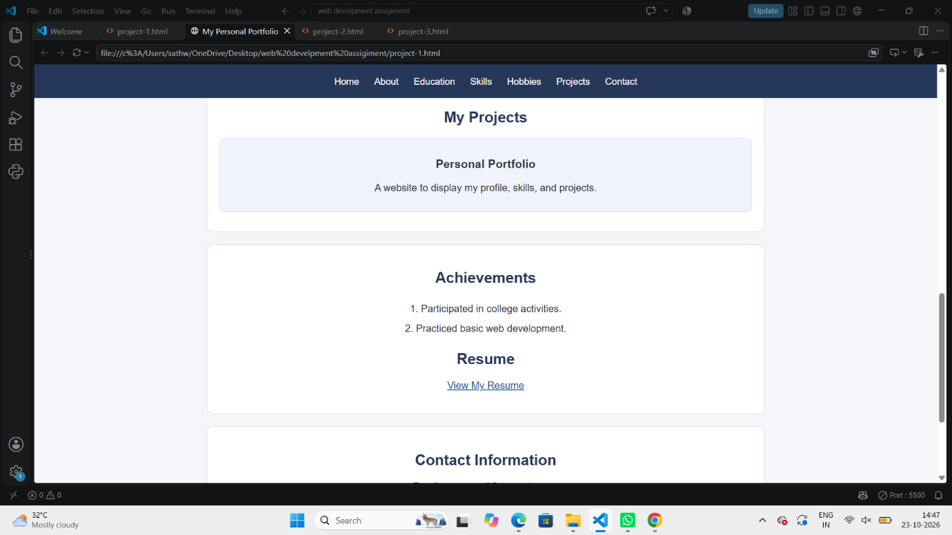
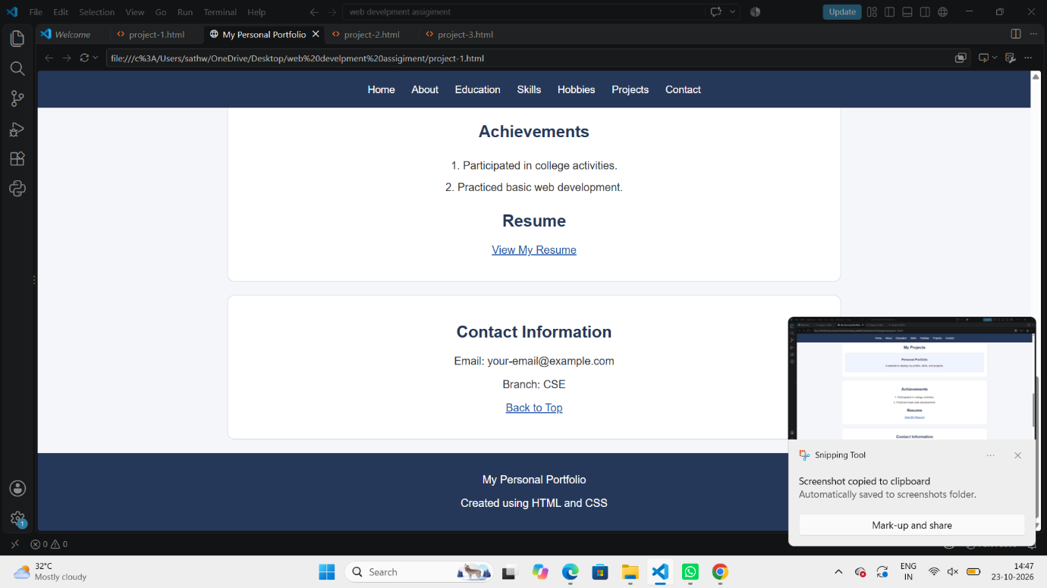

Topic : Bakery and Cake Shop Website
1. Aim
To design a bakery website using HTML and CSS to display cakes, pastries, cookies, custom cake designs, special offers, and contact information.
2. Description:
This project is a simple bakery website named Sweet Treats Bakery. HTML is used to create the structure and content of the webpage, while an external CSS file is used to style the website. It displays different bakery products with their descriptions and prices, along with customized cake options, seasonal offers, and contact details.
3. Main Features:
- Navigation Bar: Provides links to Home, Cakes, Pastries, Cookies, Offers, and Contact.
- Header Section: Displays the bakery name, tagline, and welcome information.
- Special Cakes: Shows chocolate cake, Black Forest cake, and birthday cake with prices.
- Pastries: Displays chocolate and vanilla pastries with their prices.
- Cookies: Shows chocolate cookies and butter cookies with prices.
- Custom Cake Designs: Lists birthday, wedding, photo, and customized theme cakes.
- Special Offers: Displays seasonal discounts and festival offers.
- Contact Section: Provides the bakery's address, phone number, email, and opening hours.
- Back to Top: Allows visitors to return to the home section.
- Footer: Displays the bakery name and tagline.
4. HTML and CSS Used:
Tag / Property Purpose
<html> | Defines the HTML document.
<head> | Contains the title and stylesheet link.
<title> | Sets the webpage title.
<link> | Connects the external CSS file.
<body> | Contains the visible webpage content.
<nav> | Creates the navigation bar.
<a> | Creates links between webpage sections.
<div> | Groups related content into sections.
<h1>, <h2>, <h3> | Display headings.
<p> | Displays descriptions and prices.
<ul> and <li> | Display lists of custom cake options.
<footer> | Defines the bottom section of the webpage.
class | Groups elements for CSS styling.
id | Identifies sections for navigation.

5. Conclusion:
This project demonstrates how HTML and CSS can be used to create a simple and attractive bakery website. It helps students understand webpage structure, navigation links, product presentation, pricing, and external CSS styling.
Output:
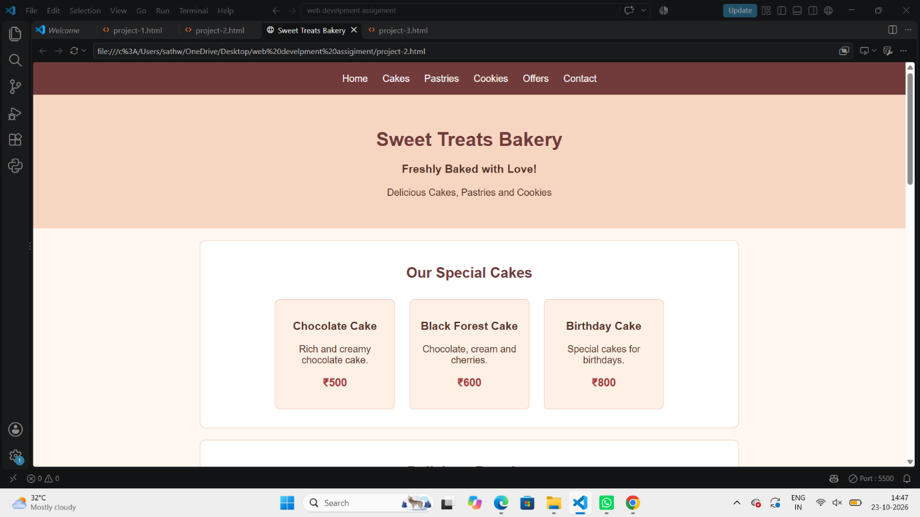
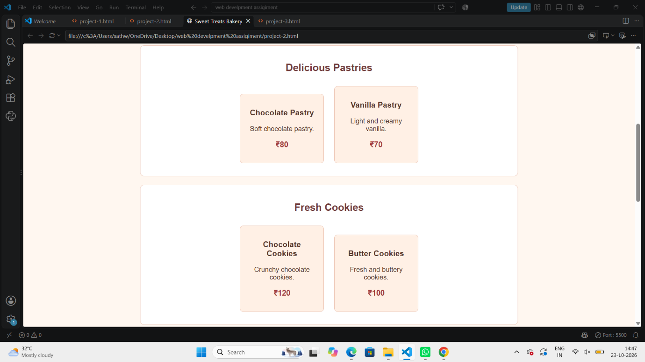
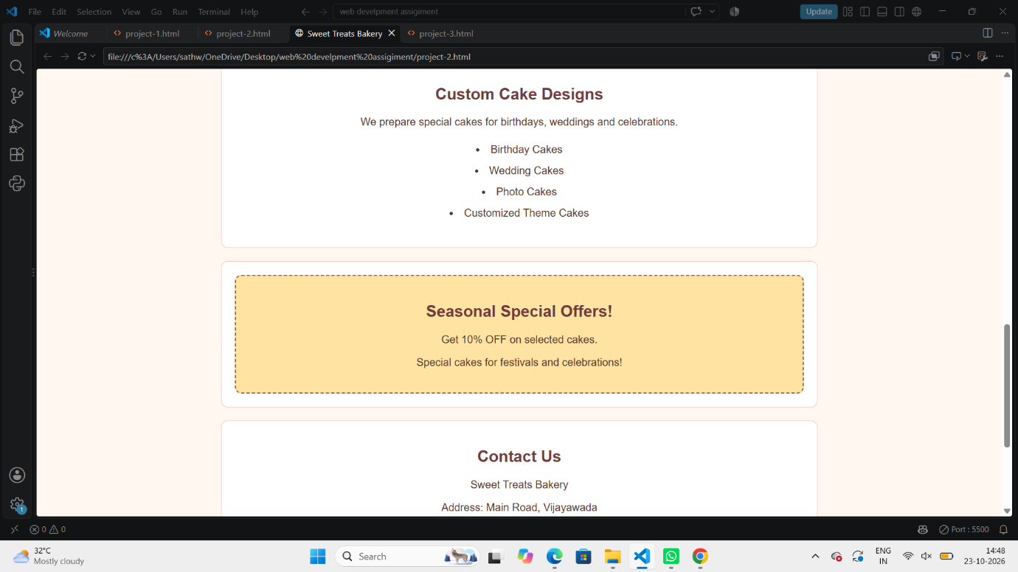
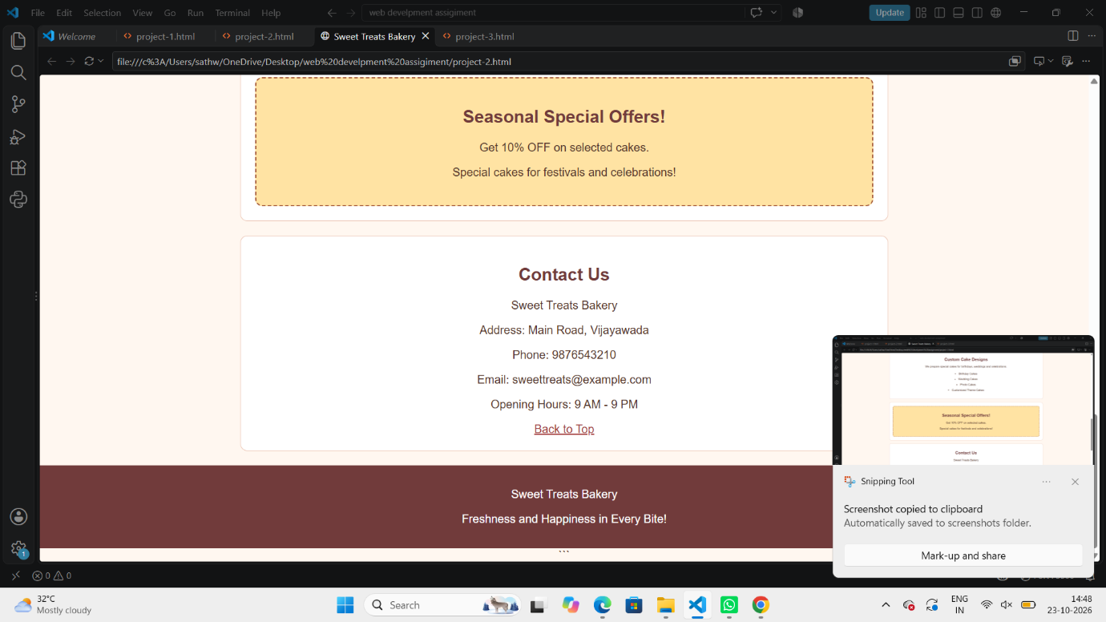

Topic : Project And Task Management Dashboard Website
1. Aim:
To design a project management dashboard using HTML and CSS to display project summaries, task progress, deadlines, priorities, Kanban task boards, and team members.
2. Description:
This project is a simple Project Management Dashboard designed to organize and track project activities. HTML is used to create the structure of the webpage, while an external CSS file is used for styling and layout. The dashboard displays project statistics, progress bars, task statuses, deadlines, priorities, and team member details.
3. Main Features:
- Navigation Bar: Provides links to Home, Projects, Tasks, and Team.
- Header: Displays the dashboard title and tagline.
- Project Summary: Shows the total number of projects, completed tasks, and pending tasks.
- Project Progress: Displays project completion percentages using progress bars.
- Kanban Task Board: Organizes tasks into To Do, In Progress, and Completed columns.
- Task Deadlines: Displays the deadlines or completion dates of tasks.
- Priority Levels: Identifies tasks as high, medium, or low priority.
- Team Members: Displays the names and roles of team members.
- Footer: Displays the project title and technologies used.
4. HTML and CSS Used:
Tag / Property Purpose
<html> Defines the HTML document.
<meta> Specifies character encoding and viewport settings.
<link> Connects the external CSS file.
<nav> Creates the navigation bar.
<header> Displays the dashboard heading.
<div> Groups related content into sections.
<h1> to <h4> Display headings at different levels.
<p> Displays task details and other text.
<footer> Defines the bottom section of the webpage.
class Groups elements for CSS styling.
id Identifies sections for navigation.
width Sets the width of progress bars.
priority classes Help style different task priority levels.

5. Conclusion:
This project demonstrates how HTML and CSS can be used to create a project management dashboard. It helps students understand webpage layout, project summaries, progress indicators, task organization, priority levels, and team member sections.
Output :